MAD LAB CYCLE 2  
1.**Create 2 Activities from 1st Activity on click move to 2nd activity (Using Intent)**

Activity main.xml

<LinearLayout android:layout_height="match_parent"

android:layout_width="match_parent"

android:orientation="vertical"

xmlns:android="http://schemas.android.com/apk/res/android"

xmlns:tools="http://schemas.android.com/tools"

tools:context=".MainActivity">

<TextView

android:id="@+id/T1"

android:layout_width="match_parent"

android:layout_height="92dp"

android:text="go to next page" />

<Button

android:layout_width="match_parent"

android:layout_height="wrap_content"

android:text="submit"

android:id="@+id/B1"/>

</LinearLayout>

second acyivity main

<LinearLayout android:layout_height="match_parent"

android:layout_width="match_parent"

android:orientation="vertical"

xmlns:android="http://schemas.android.com/apk/res/android"

xmlns:tools="http://schemas.android.com/tools"

tools:context=".secondactivity">

<TextView

android:id="@+id/T2"

android:layout_width="match_parent"

android:layout_height="92dp"

android:text="go to next page" />

<Button

android:layout_width="match_parent"

android:layout_height="wrap_content"

android:text="back"

android:id="@+id/B2"/>

</LinearLayout>

main activity.java

package com.example.sjcet.cycle2prgm1;

import android.content.Intent;

import android.support.v7.app.AppCompatActivity;

import android.os.Bundle;

import android.view.View;

import android.widget.Button;

public class MainActivity extends AppCompatActivity {

private Button b1;

@Override

protected void onCreate(Bundle savedInstanceState) {

super.onCreate(savedInstanceState);

setContentView(R.layout.*activity_main*);

b1=findViewById(R.id.*B1*);

b1.setOnClickListener(new View.OnClickListener() {

@Override

public void onClick(View v) {

Intent intent = new Intent(MainActivity.this, secondactivity.class);

startActivity(intent);

}

});

}

}

second activity.java

package com.example.sjcet.cycle2prgm1;

import android.content.Intent;

import android.support.v7.app.AppCompatActivity;

import android.os.Bundle;

import android.view.View;

import android.widget.Button;

public class secondactivity extends AppCompatActivity {

private Button b2;

@Override

protected void onCreate(Bundle savedInstanceState) {

super.onCreate(savedInstanceState);

setContentView(R.layout.*activity_secondactivity*);

b2=findViewById(R.id.*B2*);

b2.setOnClickListener(new View.OnClickListener() {

@Override

public void onClick(View v) {

Intent intent = new Intent(secondactivity.this, MainActivity.class);

startActivity(intent);

}

});

}

}

**output**

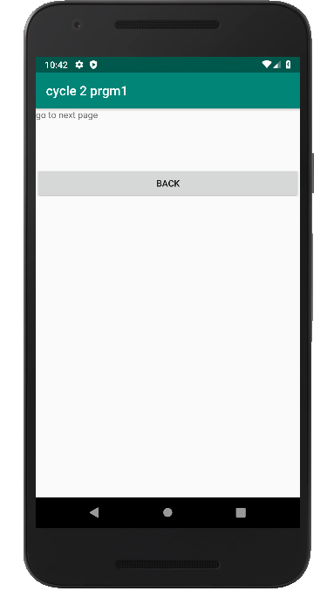

***2* Create an Activity and move to facebook login page on a button click(making use of Intent).**

*<?*xml version="1.0" encoding="utf-8"*?>*

<LinearLayout android:layout_width="match_parent"

android:layout_height="match_parent"

android:orientation="vertical"

xmlns:android="http://schemas.android.com/apk/res/android">

<Button

android:onClick="click"

android:layout_width="wrap_content"

android:layout_height="wrap_content"

android:text="Facebook login"

android:layout_centerInParent="true"/>

</LinearLayout>

package com.example.sjcet.facebook;

import android.content.Intent;

import android.net.Uri;

import android.support.v7.app.AppCompatActivity;

import android.os.Bundle;

import android.view.View;

public class MainActivity extends AppCompatActivity {

@Override

protected void onCreate(Bundle savedInstanceState) {

super.onCreate(savedInstanceState);

setContentView(R.layout.*activity_main*);

}

public void click(View view) {

String url ="https://www.facebook.com";

Intent i =new Intent(Intent.*ACTION_VIEW*);

i.setData(Uri.*parse*(url));

startActivity(i);

}

}

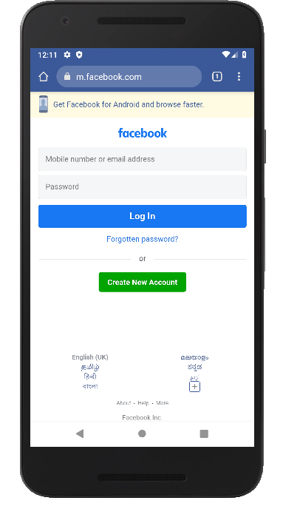**output**

**3.Read message from 1st Activity and pass it onto the 2nd Activity on a button click.**

Activity main.xml

<LinearLayout android:layout_height="match_parent"

android:layout_width="match_parent"

android:orientation="vertical"

xmlns:tools="http://schemas.android.com/tools"

tools:context=".MainActivity"

xmlns:android="http://schemas.android.com/apk/res/android">

<EditText

android:layout_width="match_parent"

android:layout_height="wrap_content"

android:text="enter the text"

android:id="@+id/ED1"/>

<Button

android:layout_width="match_parent"

android:layout_height="wrap_content"

android:onClick="click"

android:id="@+id/B1"/>

</LinearLayout>

second acyivity main

<LinearLayout android:layout_height="match_parent"

android:layout_width="match_parent"

android:orientation="vertical"

xmlns:android="http://schemas.android.com/apk/res/android"

xmlns:tools="http://schemas.android.com/tools"

tools:context=".newactivity">

<EditText

android:layout_width="match_parent"

android:layout_height="wrap_content"

android:text="enter the text"

android:id="@+id/ED2"/>

</LinearLayout>

main activit.java

package com.example.sjcet.c2pg3;

import android.content.Intent;

import android.support.v7.app.AppCompatActivity;

import android.os.Bundle;

import android.view.View;

import android.widget.Button;

import android.widget.EditText;

public class MainActivity extends AppCompatActivity {

@Override

protected void onCreate(Bundle savedInstanceState) {

super.onCreate(savedInstanceState);

setContentView(R.layout.*activity_main*);

}

public void click(View view) {

Button b1 = (Button)findViewById(R.id.*B1*);

EditText E1=(EditText)findViewById(R.id.*ED1*);

String s = E1.getText().toString();

Intent i= new Intent(getApplicationContext(), newactivity.class);

i.putExtra("message",s);

startActivity(i);

}

}

new activity

package com.example.sjcet.c2pg3;

import android.content.Intent;

import android.support.v7.app.AppCompatActivity;

import android.os.Bundle;

import android.widget.EditText;

public class newactivity extends AppCompatActivity {

EditText msg;

@Override

protected void onCreate(Bundle savedInstanceState) {

super.onCreate(savedInstanceState);

setContentView(R.layout.*activity_newactivity*);

msg=(EditText)findViewById(R.id.*ED2*);

Intent i= getIntent();

String s=i.getStringExtra("message");

msg.setText(s);

}

}

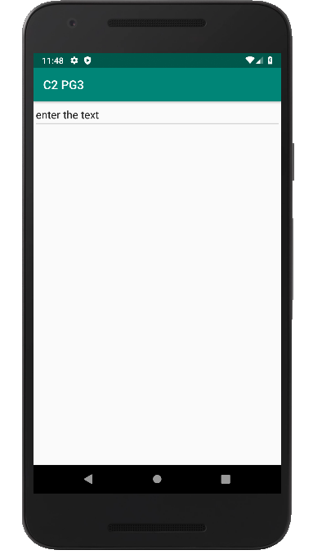**output**

**4.Create registration page with full validation and pass the information to the second activity (using shared preference)**

**Mandatory fields : fname,lname,gender,email,phone number,password,dob(date picker)**